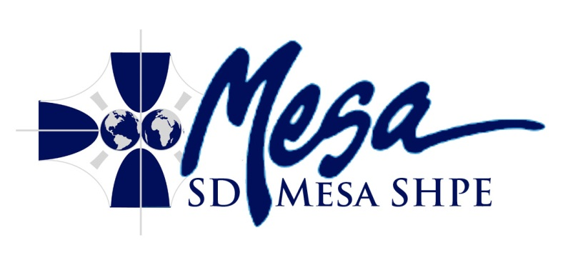
Agenda
San Diego Mesa SHPE Club
Wednesday, November 7th, 2012 2:00 PM
RM S-208
- Call To Order: Meeting officially commences.
- Roll Call: Roll call of officers is taken, and attendance sheet is passed around.
- Acceptance of Agenda
- Acceptance of Previous Minutes
- Reports
- Public Forum
- Discussion Items:
  - Small Project Meeting Space
  - Club Shirts
  - Membership and Removal
  - Fundraising
  - Google Account
  - Shadow Day
  - Treasurer Class
  - AUVSI Conference
  - Final appreciations
- Action Items:
  - Walk on Water Competition Expenses
- Roundtable: Time for announcements, etc. No discussion at this time
- Recap: The secretary will read off all important notes of the meeting
- Adjournment

ALL STUDENTS WELCOME TO ATTEND

