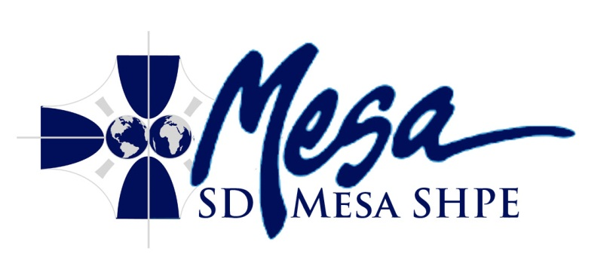
Meeting Minutes
San Diego Mesa SHPE Club
Wednesday, October 24th, 2012 2:00 PM
RM S-208
Call To Order: 14:06
Roll Call:
Officers:
President: Tom Aristide
Vice President: Zeferino Rincon
Treasurer: Mitch Struck
Professor Mo: Present
Members:
Louis Renova
Steven Ciolino
Robert Will
Thomas DeLeon
Trevor Conley
Mitchell Struck
Mark Hertzel
Sean Ueda
Acceptance of Agenda: Thomas Aristide moved to accept the agenda, Robert Will seconds
Acceptance of Previous Minutes: Robert will moved to approve minutes with an ammended date. Thomas Aristide seconds.
Reports:
President: The walk on water was successful, SD Mesa SHPE won 3 medals, 2 for tanker SHPE, and 1 for MO. Awards were display. Local news covered story. Thanked all participants for helping with WoW competition.
Vice President: UCLA tap going on, ensure you complete all necessary paperwork to avoid losing preference. Nov 3rd AWIS meeting at SDSU
Treasurer: mesa premed/pharm Halloween ice skate party on oct 26 from 7-10pm. Includes costume contest, happenning at San Diego Ice arena. UC application workshop going on Nov 5 MV33 from 2-3pm. College essay writing workshop nov 7 g107 to help with college admissions essays.
ICC: Nothing to report
Secretary: Nothing to report
Public Forum:preference.
Presentations:
- Club Co-operation: Thomas De Leon (sd.icc.secretary@gmail.com, thomasdeleon1@yahoo.com): Mesa robotics will be fundraising late November. Selling t-shirts and doing green screning for students. Participating in robotics competition in april, making an autonomous maze robot, still accepting applicants. Friday 12-2 room k303 for Robotics Club meetings. Robotics club wants more inter-organization and co-operation between the clubs.
- Fundraising: Thomas: Catapult competition, buy tickets and try to get closest for small prizes.
- Membership: Thomas: Creating a business card to hand out to interested students to try and increase membership. Calling for designs and feedback, likely to happen late in this semester or the next.
- T-Shirts: Thomas: We have 3 different options for printing shirts, we will get cost estimates in order to decide. Club logo will be on shirts, further ideas will be fielded during later discussion.
- SHPE Membership Dues: Thomas: We need to decide on a date when the total 10$ will be due for members. After the meeting anyone available can log on and become a national member.
- SHPE National Membership Advantages: Give access to events, job application assistance, and qualification for scholarships. Resume's look better with SHPE on them!
- Competitions: Tom: Next one is USD WoW, if anyone wants to join one please bring it to the meetings. We are looking into a truss building competition to host at the college in order to increase interest and visibility.
Discussion and Action Items:
- SD Mesa SHPE Website: Thomas moved to change current web page to sdmesashpe.weebly.com. Bo seconded, 10 in favor, 0 opposed, 0 abstained.
- Amend constitution to change project coordinator. Alterations of section 8, and section 1.3 will be required. This is in the spirit of ensuring interested parties head each project, and it does not preclude officers from heading projects. Draft will be sent out with next agenda for consideration and action at the next meeting.
- Officer Elections: 0 absentee ballots were received. 11 members were present for voting, the number of votes received by each name.
  - Nominations for President
    - Thomas Aristide 11
  - Nominations for Vice President
    - Zeferino Rincon 11
  - Nominations for Secretary
    - Robert Will 10
  - Nominations for Webmaster
    - Trevor Conley 11
  - Nominations for Membership Director
    - Mitchell Struck 11
  - Nominations for Treasurer:
    - Mark Hertzel 3
    - Sean Ueda 8
  - Nominations for ICC Representative
    - Nate Falwell 11
Roundtable: Professor Mo sent out e-mails about scholarship information, webmaster will start publishing this information on the website.
Adjournment: 15:16

