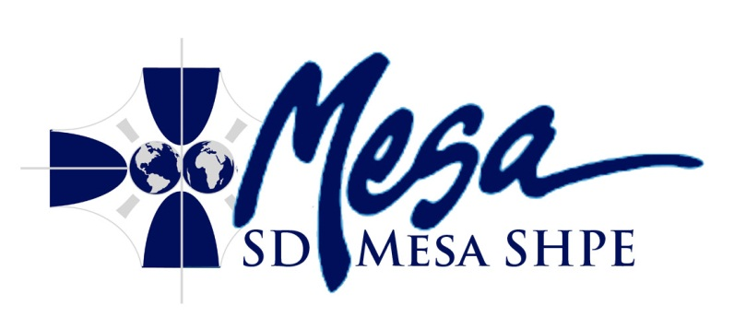
Minutes
San Diego Mesa SHPE Club
Wednesday, October 31st, 2012 2:00 PM
RM S-208
- Call To Order: 14:31
- Roll Call:
Officers:
President: Tom Aristide
Vice President: Zeferino Rincon Not Present
Treasurer: Sean Ueda Not Present
Membership Coordinator: Mitch Struck Not Present
Webmaster: Trevor Conley
Secretary: Robert Will
Professor Mo: Present
Members:
Louis Renova
Steven Ciolino
Hannah Garner
- Acceptance of Agenda: Tom Aristide moves to accept agenda, Robert Will seconds.
- Acceptance of Previous Minutes: Tom Aristide moves to accept agenda, Robert Will seconds.
- Reports
President: Engineer's week is 17-23 February 13, this might be a good time to consider outreach. Now is a good time to start an annual and semester outreach plan to encourage membership and involvement.
ICC: Treasurer Workshop Friday 07 November 12
Webmaster: Nothing to Report
Secretary: Nothing to Report
- Public Forum
- Discussion Items:
  - Expenditure for Walk on Water Competition (Tom Aristide)
  - Ideas to Host Competitions (Robert Will)
  - Final appreciations
  - Approval of Expenditure for Walk on Water Competition (Tabled for consideration in one week)
- Roundtable:
Tom Aristide: Upon further investigation into the club constitution, there is no reason to amend the constitution since the intent is clear upon further reading into the project manager position. This item will not re-appear on agenda.
Robert Will: Superconductor levitation may be good for use as a demonstration or possibly in a competition. We should talk to the advisor to see about getting liquid nitrogen.
- Recap: The secretary will read off all important notes of the meeting
- Adjournment: 1500

ALL STUDENTS WELCOME TO ATTEND

